Woodcraft
Design Document

Version 1.0



Group Id: F25PROJECTEB2A1

Supervisor Name: Abdul Majid Khokhar

Revision History
Date (dd/mm/yyyy) | Version | Description | Author
12/04/2026 | 1.0 | A complete and structured version of the design document including:  System Architecture, ERD, Sequence Diagrams, Class Diagram, Database Design, Interface Design, and Test Cases. | Bc210202812

Table of Contents

Introduction of Design Document 4
Entity Relationship Diagram (ERD) 6
Sequence Diagrams 7
3. UC03 — Track Order Status 9
4. UC04 — Manage Raw Materials 10
5. UC05 — Assign Worker to Job 11
6. UC06 — Generate Invoice 12
7. UC07 — Record Payment 13
8. UC08 — Track Employee Performance 13
9. UC09 — Generate Reports & Analytics 14
10. UC10 — Update Task Progress 14
11. UC11 — Track Work Hours & Wages 15
12. UC12 — Auto-Decrease Stock 16
13. UC13 — Low-Stock Alert 16
14. UC14 — Generate Cost Estimation 17
Architecture Design Diagram 17
Class Diagram 22
Database Design 24
Interface Design 25
Test Cases 29

Introduction of Design Document
This Design Document presents the technical design of the Woodcraft Management System, developed in accordance with the approved Software Requirements Specification (SRS). While the SRS defines what the system should do, this document describes how the system is designed to fulfill those requirements.

The Woodcraft Management System is implemented as a full-stack web application using modern technologies:
- Next.js (App Router) for full-stack development, handling both frontend user interface and backend API logic
- MongoDB as the NoSQL database for efficient data storage and management

This document provides detailed technical representations of the system, including:
- Entity Relationship Diagram (ERD) to define database entities and relationships
- Architecture Design Diagram illustrating the overall system structure and component interaction
- Sequence Diagrams showing interactions between users, application layers, and the database
- Class Diagram representing core system entities and their relationships
- Database Design describing collections and data organization
- Interface Design outlining key system screens and user interaction flow
- Test Cases to validate system functionality

The purpose of the design phase is to transform system requirements into a clear and structured technical solution. It acts as a bridge between analysis and development, ensuring that the system is properly organized before implementation begins.

This phase provides several benefits:
- Clearly defines system architecture and module responsibilities
- Ensures the database structure supports all functional requirements
- Identifies potential technical risks before development
- Improves maintainability through modular design
- Supports scalability as the system grows
- Reduces rework by eliminating ambiguity before implementation

By preparing this design document, the project ensures that development follows a clear technical blueprint, resulting in a reliable, scalable, and maintainable Woodcraft Management System.

Entity Relationship Diagram (ERD)
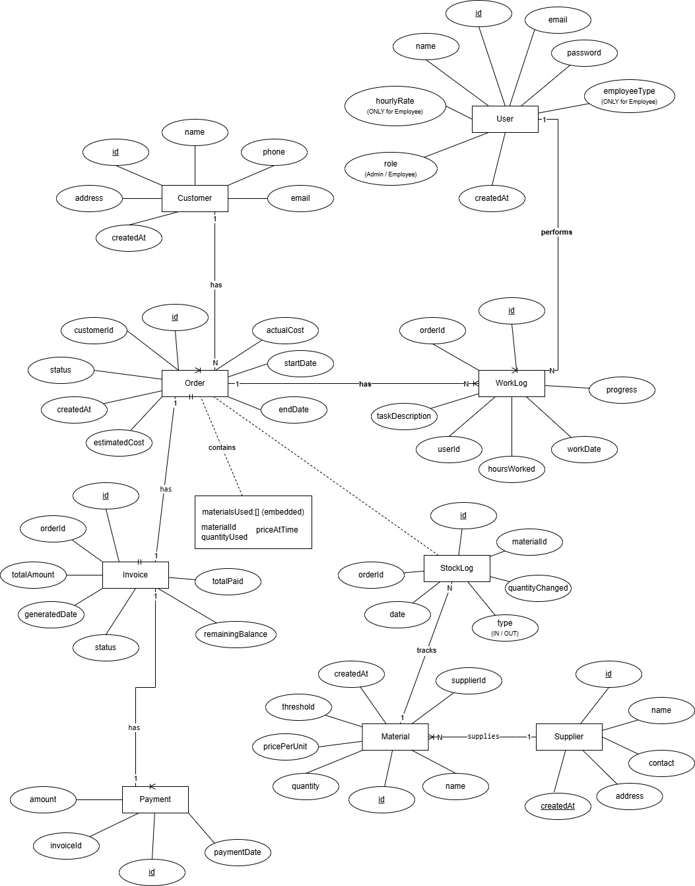

Sequence Diagrams

UC01 — Register Employee
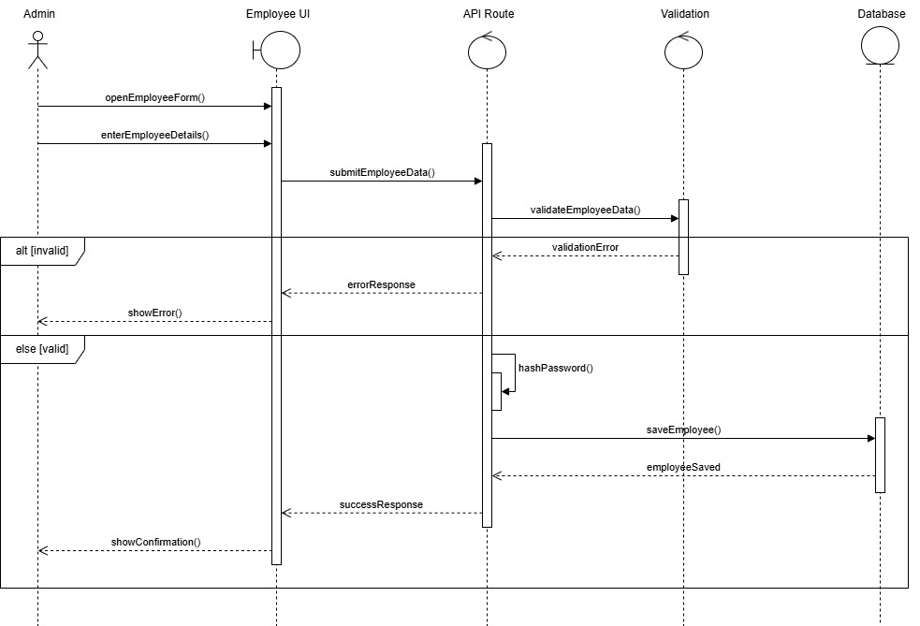

UC02 — Register Customer
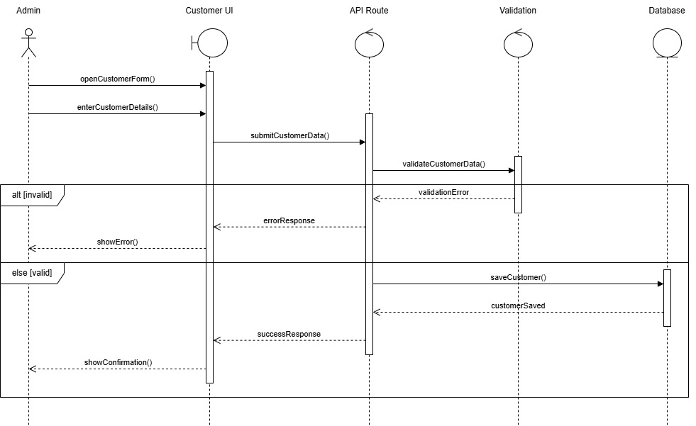

UC03 — Create Order
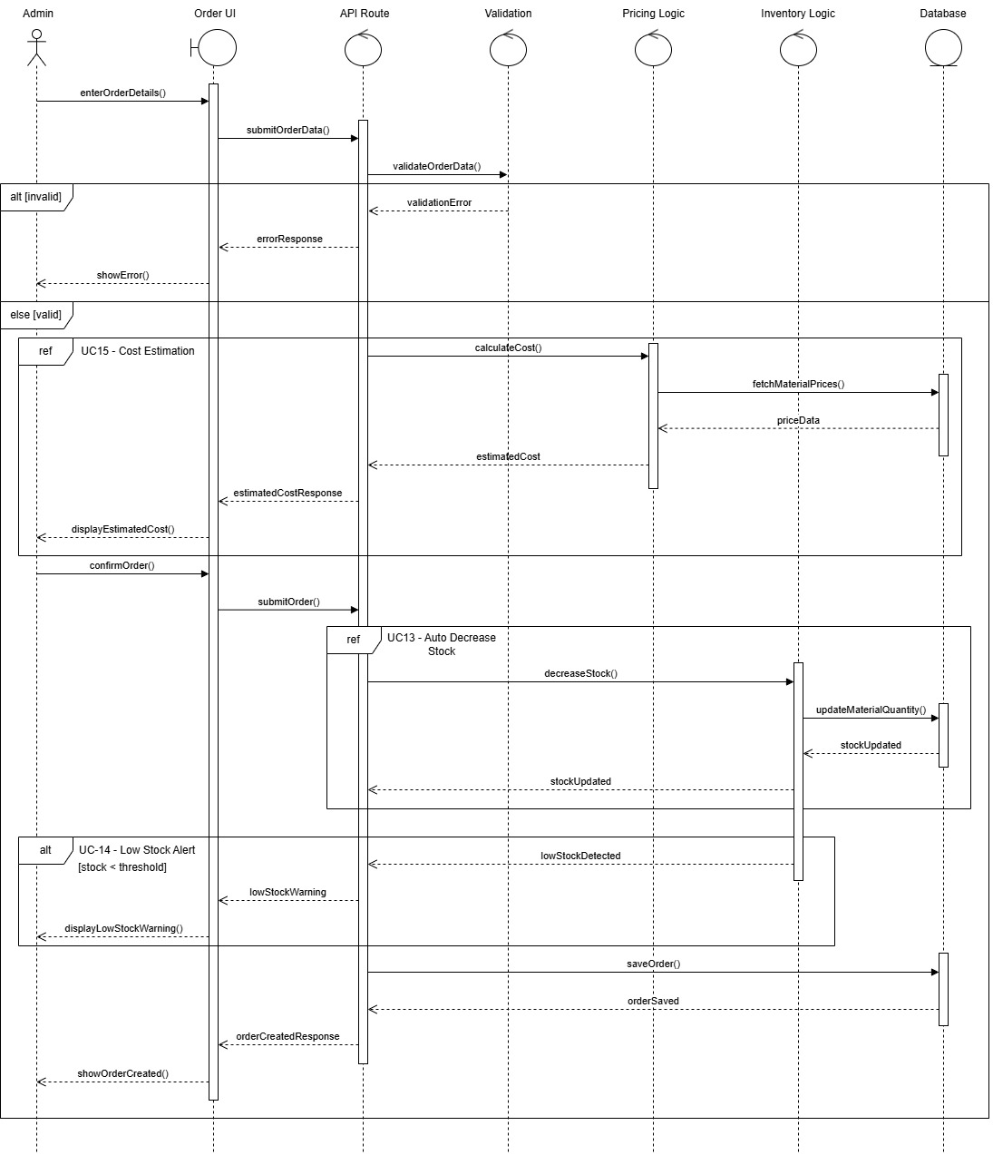

UC04 — Track Order Status
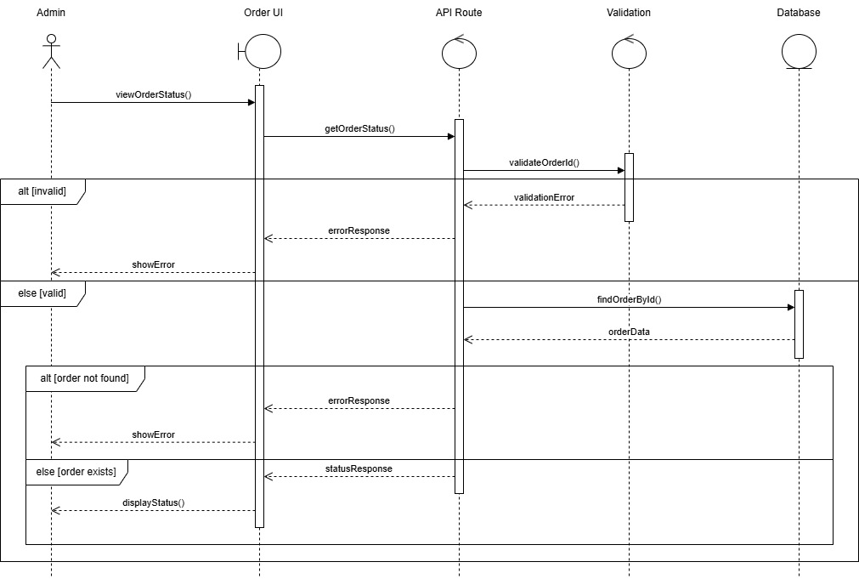

UC05 — Manage Raw Materials
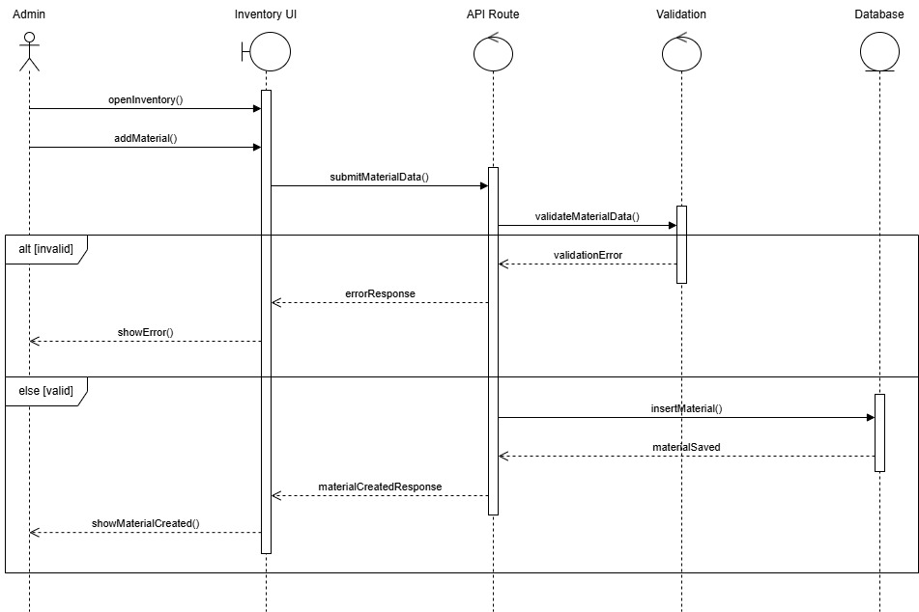

UC06 — Assign Worker to Job
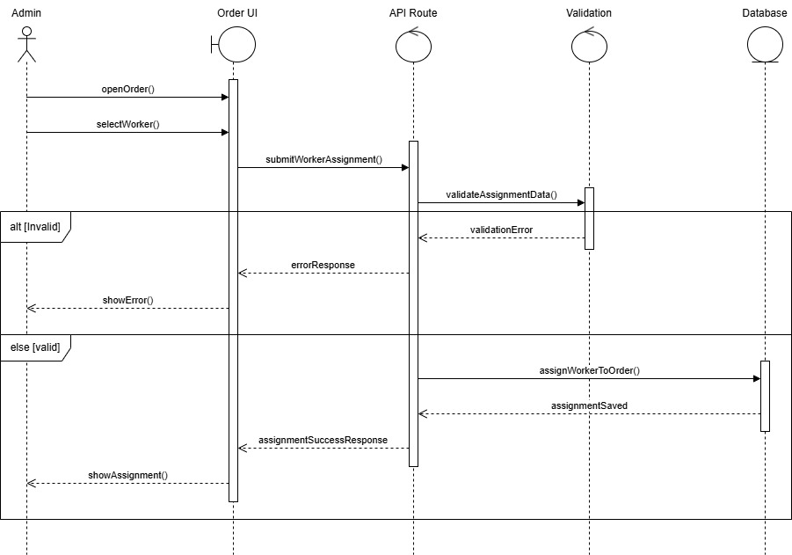

UC07 — Generate Invoice
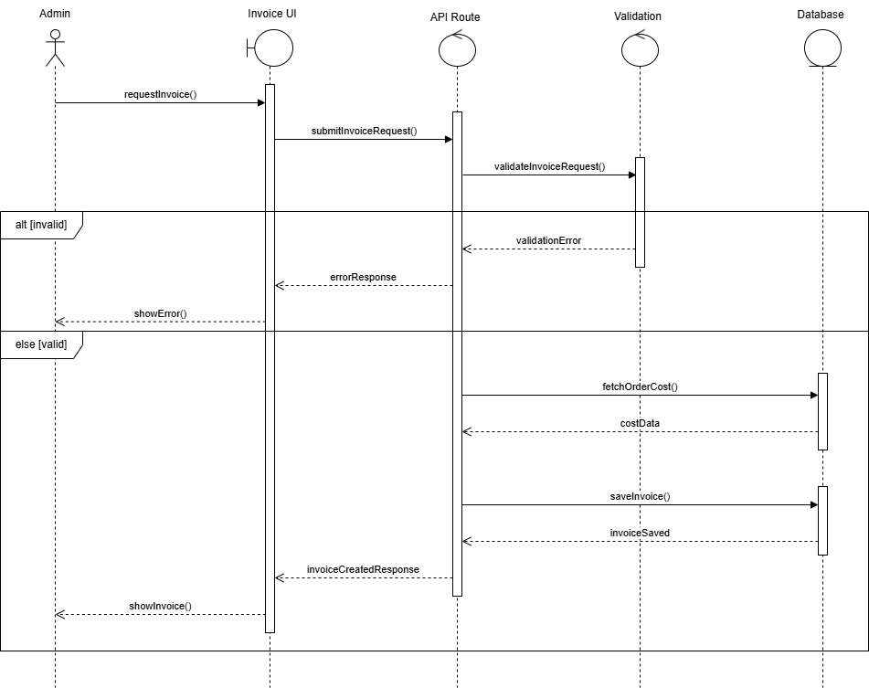

UC08 — Record Payment
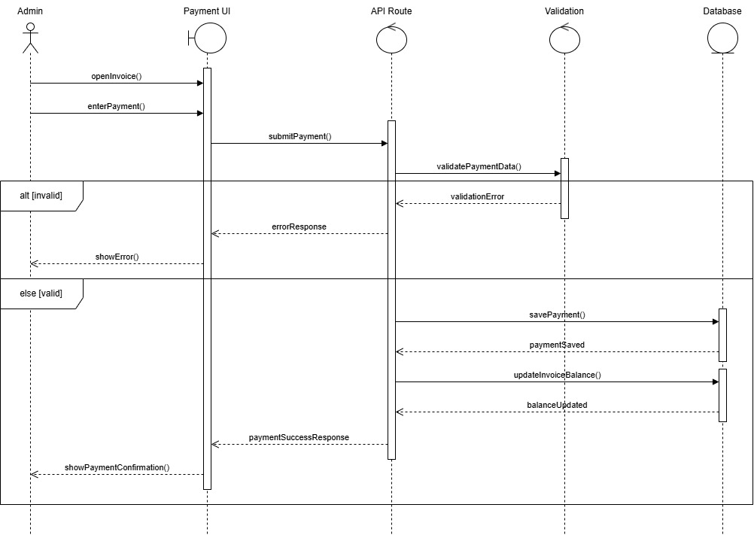

UC09 — Track Employee Performance
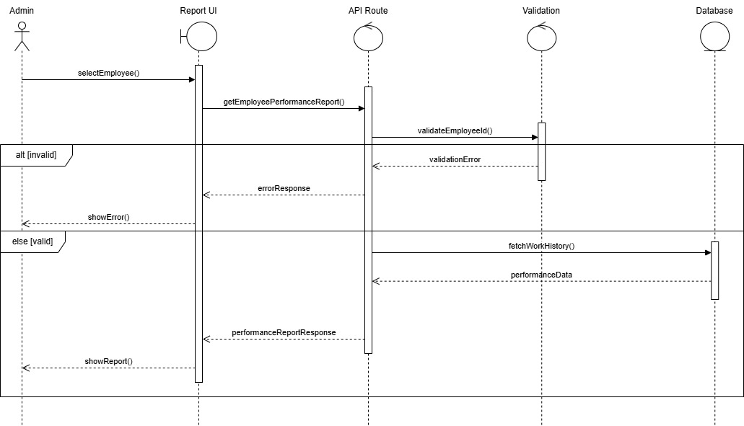

UC10 — Generate Reports
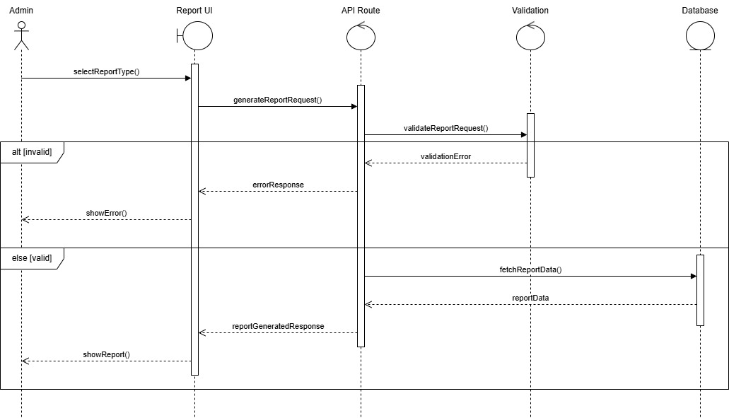

UC11 — Update Task Progress
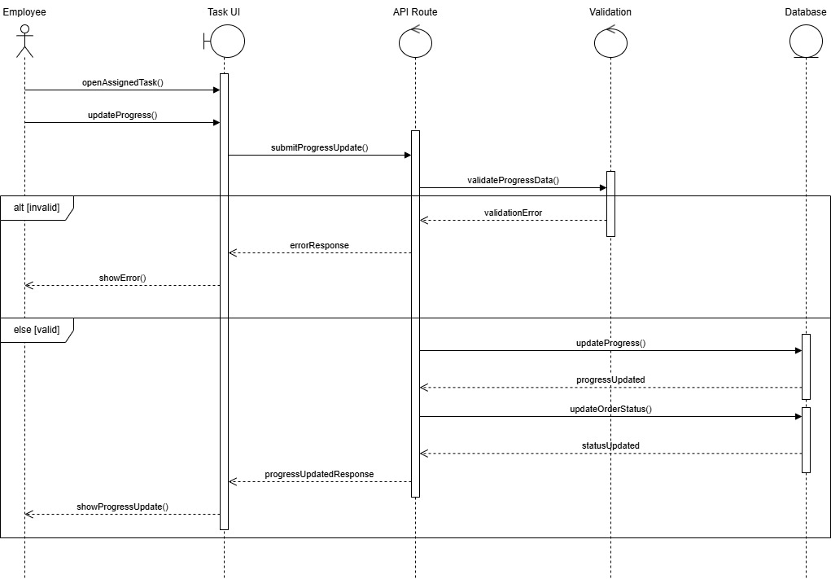

UC12 — Track Work Hours & Wages
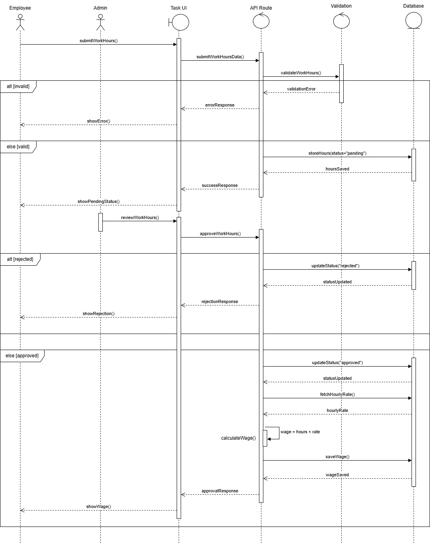

UC13 — Auto Decrease Stock
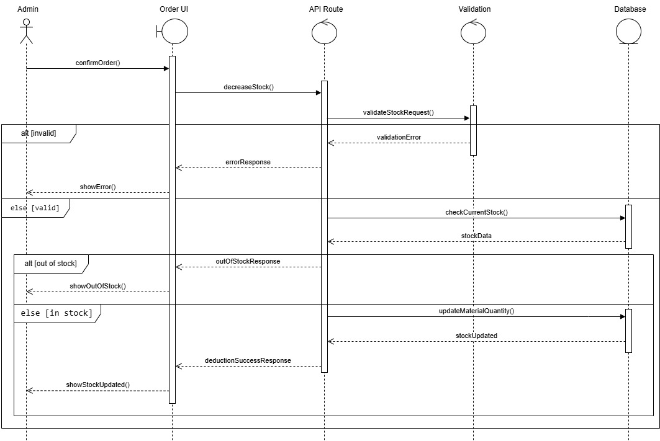

UC14 — Low Stock Alert
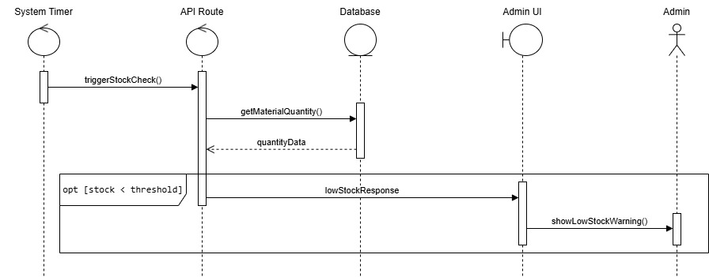

UC15 — Generate Cost Estimation
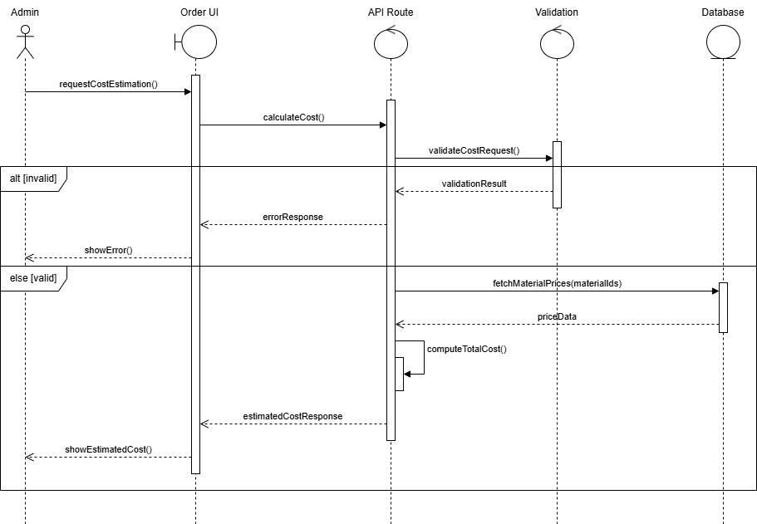

Architecture Design Diagram
The Woodcraft Management System follows a layered architecture consisting of the Presentation Layer, Application Layer, and Data Layer. This architectural approach ensures clear separation of concerns, making the system more maintainable, scalable, and secure.

1. Presentation Layer (Frontend)
The Presentation Layer represents the user interface of the system and handles all user interactions.

- Implemented using Next.js (React-based frontend framework)
- Provides interactive interfaces for managing system operations

Key interfaces include:

- Admin Dashboard UI
- Employee Task UI
- Order Management UI
- Inventory Management UI
- Invoice UI
- Payment UI

Users interact with the system through these interfaces to perform daily operational tasks.

2. Application Layer (Backend / Business Logic)
The Application Layer contains the core backend logic of the system and is implemented using Next.js API Routes.

This layer is responsible for:
- Processing requests received from the frontend
- Communicating via HTTP requests and JSON responses
- Validating input data and enforcing business rules
- Executing core application logic

The Application Layer is divided into the following components:

API Routes:
- Employee Routes – manage employee-related actions
- Customer Routes – handle customer operations
- Order Routes – manages order creation and updates
- Inventory Routes – handle material and stock operations
- Invoice Routes – generate and manage invoices
- Payment Routes – processes payments
- Report Routes – handle reporting features
- Task Routes – manage employee tasks

Validation Layer:
This component ensures that all incoming data is properly validated before processing.
- Input validation
- Business rule checking
- Error handling for invalid requests

Business Logic (Services):
- Customer Service – manages customer-related logic
- Employee Service – handles employee operations
- Order Service – processes orders and status updates
- Inventory Service – manages stock updates and deductions
- Invoice Service – generates invoices
- Payment Service – processes payments and updates balances
- Task Service – manages task progress and updates
- Report Service – generates reports and analytics
These components work together to ensure that all business rules are properly enforced.

3. Data Layer (Database)
The Data Layer is responsible for storing and managing all persistent data using MongoDB.

Key collections include:

- Users
- Customers
- Orders
- Materials
- Suppliers
- WorkLogs
- Invoices
- Payments
- StockLogs

The application layer interacts with the database to perform create, read, update, and delete (CRUD) operations.

Architecture Benefits

This layered architecture provides several advantages:
- Clear separation of concerns between frontend, backend, and database
- Improved maintainability and scalability
- Better organization of business logic
- Easier debugging and testing
- Flexibility for future system enhancements

Overall, this architecture enables efficient management of woodcraft workshop operations while supporting future system growth.
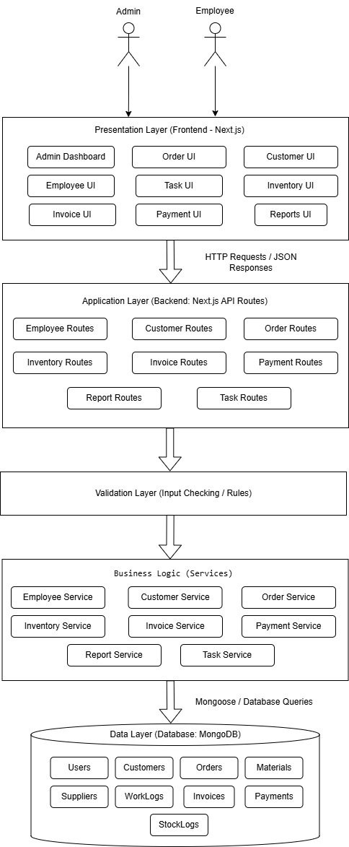

Class Diagram

The class diagram represents the structural design of the Woodcraft Management System. It illustrates the key domain entities, their attributes, and relationships, providing a clear overview of how data is organized and connected within the system.
Core Domain Models (Entities)
Order and Inventory:
Each Order stores the materials used within an embedded structure called materialsUsed, where each item contains a materialId and quantityUsed. This approach follows MongoDB’s document-based model, allowing related data to be stored within a single document for efficient data access and performance.
Employee Management:
The User class represents system users, including both admin and employees. Employee activities are tracked using the WorkLog class, where each work log records the hours worked by a user on a specific order. This information is used for wage calculation and performance tracking.
Billing and Payments:
When an order is completed, an Invoice is generated for that order. Each invoice can have multiple Payment records, enabling support for both partial and full payments.
Overall, the class diagram focuses on the core data structure of the system, ensuring a clear and organized representation of entities and their relationships.
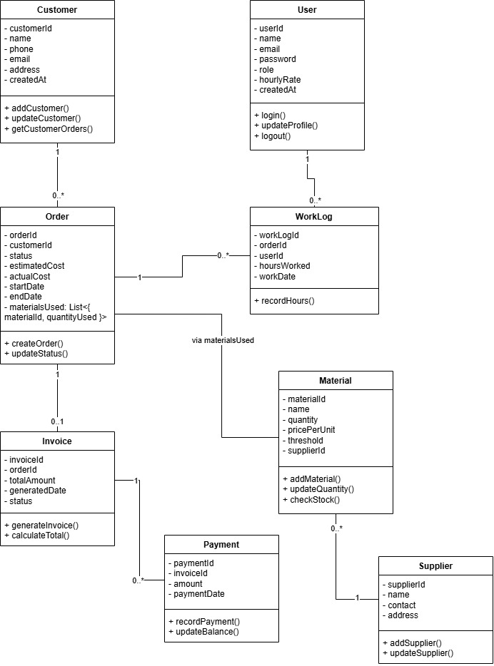

Database Design

The database of the Woodcraft Management System is implemented using MongoDB, a NoSQL document-based database. It consists of collections such as Users, Customers, Orders, Materials, Suppliers, Invoices, Payments, and WorkLogs.
The system follows a hybrid data modeling approach by combining embedded documents and references to achieve optimal performance and maintain data consistency.

Embedded Structure:
In the Orders collection, materials used in an order are stored as an embedded array (materialsUsed), where each item contains a materialId and quantityUsed. The materialId acts as a reference to the Material collection, allowing efficient linking while avoiding unnecessary duplication. This approach improves read performance by keeping frequently accessed related data within a single document.

Referential Structure:
Relationships between collections are maintained using ObjectId references. For example, Orders reference Customers, WorkLogs reference both Users and Orders, Payments reference Invoices, and Materials reference Suppliers. This ensures flexibility and normalization where required.

This design ensures efficient querying, reduced data duplication, and scalability, while aligning with MongoDB best practices for handling relational data in a document-oriented database.
